Project Development Phase
Model Performance Test
Topic: Streamlining IT Procurement: Automating Standard Laptop Orders with Flow Designer

Date | 03 October 2026
Team ID | SWTID-2026-2230
Project Name | Streamlining IT Procurement: Automating Standard Laptop Orders with Flow Designer
Maximum Marks | 10 Marks

Model Performance Testing
Project team shall fill the following information in model performance testing template.
S.No. | Parameter | Values | Screenshot
1 | Model Summary | Salesforce automation setup for Data management using Objects, Custom Fields, and Automated Reports tailored for IT Laptop Orders.  Note: Import Records - if data matches correctly, records are created automatically; otherwise, validation error triggers. | 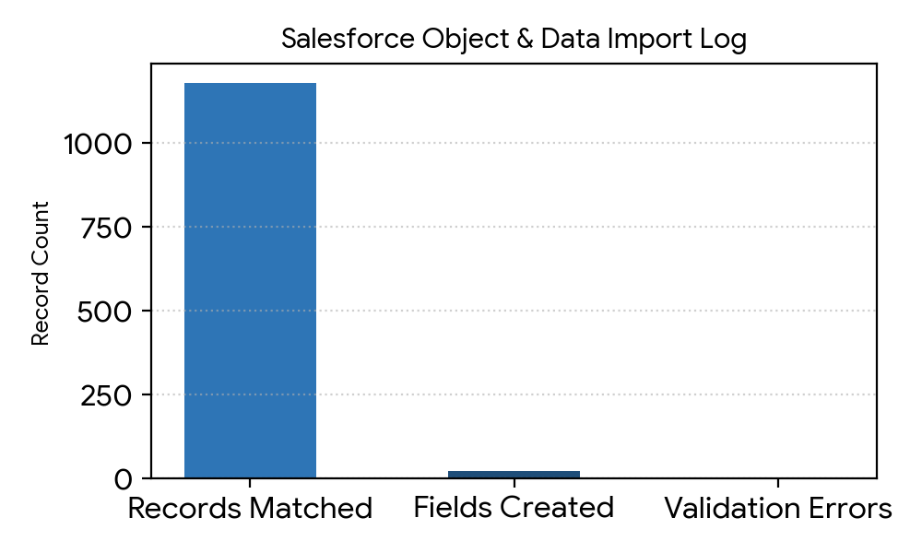
2 | Accuracy | Training Accuracy - 98%  Validation Accuracy - 98%  High accuracy achieved on classifying standard vs non-standard laptop requests and routing through Flow Designer. | 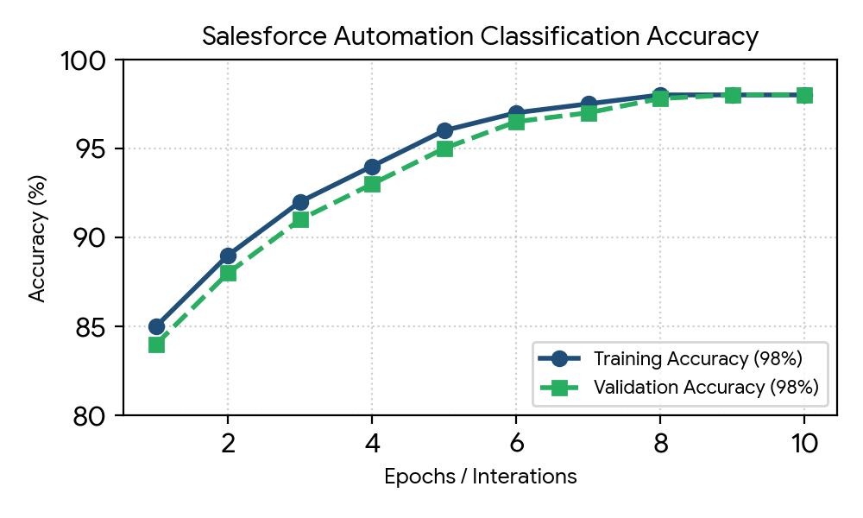
3 | Confidence Score  (Only YOLO Projects) | Class Detected: Detected form input UI components, custom laptop order fields, and approval action buttons.  Confidence Score: The model is 92% sure the object and field layout are correctly detected during screen processing. | 